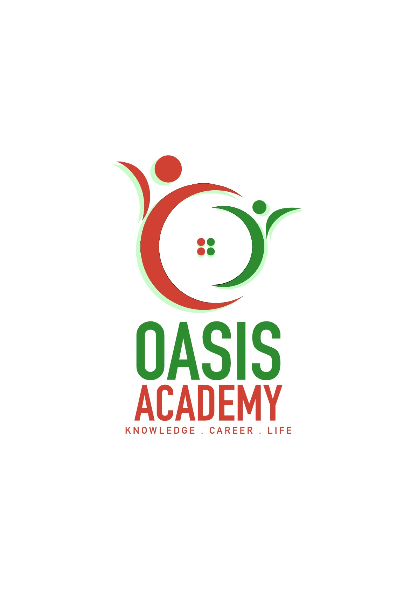

Name: Tan Khoon Eam

Login ID: tankhoon@oasis-portal.com

Course title: Tourism and Hospitality

Subject Code: BHM04

Submitted date: 11/09/2017

**Table of Contents**

|  |  |  |
| --- | --- | --- |
| **No** | **Details** | **Page** |
| 1 | Executive Summary | 2 |
| 2 | Introduction | 3 |
| 3 | Assignment Question |  |
|  | Question 1 | 4 |
|  | Question 2 | 5 - 9 |
|  | Question 3 | 10-12 |
|  | Question 4 | 13 |
| 4 | Conclusion | 14 |
| 5 | References | 15 |
| 6 | Appendix | 16 |

**Executive Summary**

In this module, I had learnt about the relation between tourism and hospitality, also the important of these two industries, based on these two industries it maintain the largest national employment base. Beside that I also learnt about the different types of tourism activities and the purpose of people traveling. Furthermore, I also learnt about the role of hospitality, about the proper ways of serving guest or visitors. I also learnt about the concept of lodging and hotel accommodation in hospitality industry. Lastly, I learnt about the entertainment industry in hospitality management and all the different types of entertainment activities.

**Introduction**

Tourism and hospitality are important source of income for many regions and countries. It also creates opportunities for employment in the service sector of the economy. Tourism is an activity that people travel around for pleasure or business. Tourism can be international or domestic. The purpose of traveling is to be staying in places outside from usual environment for not more than one consecutive year for leisure, business and other purposes. Hospitality refer to the relationship between a guest and a host, it shows the quality or disposition of receiving and treating guests and strangers in a warm, friendly, generous way. Hospitality Industry, referring to the companies or organizations which provide food and accommodation to people who are away from home. Hospitality service industry that includes lodging, event planning, theme parks, transportation, cruise line, and additional fields within the tourism industry. Majorly hospitality industry covers these three main categories which are food and beverage industry, accommodation industry and travel and tourism industry. Food and beverage is the largest element of the hospitality industry that include restaurants, fast-food caterers, catering etc. Accommodation industry include hotel, motel or lodging etc. that provide place a comfort place for people to live or stay for short period. Travel and tourism industry will cover transportation. That includes airlines, trains, cruise ships etc. Flight attendants and cruise staff function as food servers which provide food or drink and a comfortable experience for customers.

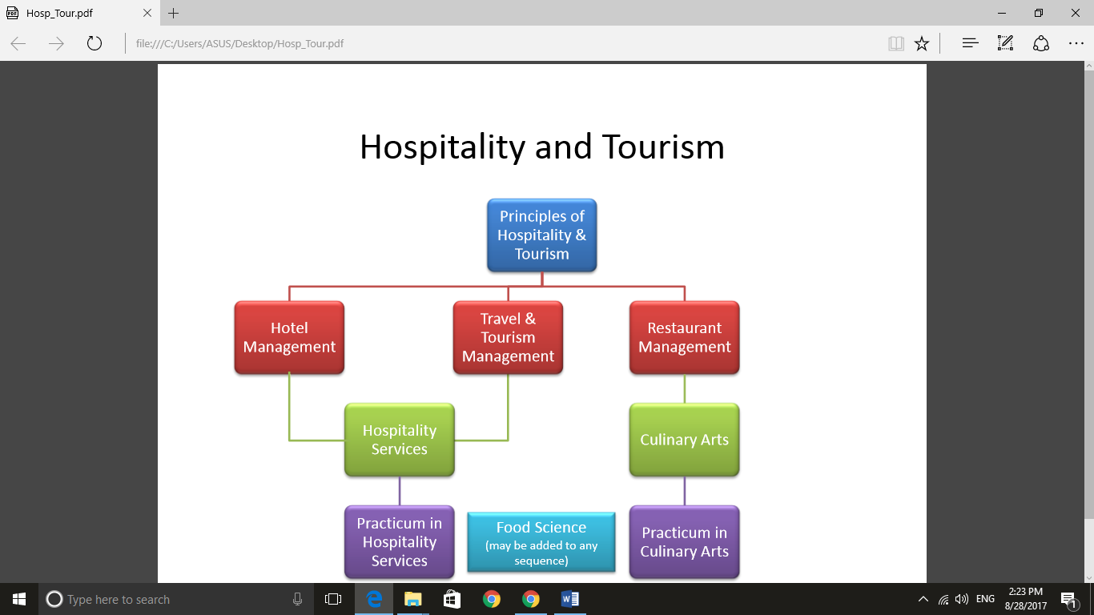

Figure 1

**Assignment Questions**

**Question 1**

Define the Tourism and Hospitality.

Explain your understanding about Hospitality industry. (20 Marks)

Tourism is an activity that people traveling from a place to another place that outside from their usual environment, for leisure, business or other purpose that not more than one consecutive year. There are three criteria are used simultaneously in order to characterize a trip as belonging to tourism. **(Tugberk Ugurlu)**

1. Tourism involves a displacement outside the usual environment, where leave the place that normally live and go to another place that new and never go before to explore and to get know about the place culture and life style.
2. Purpose of travel: must occur for any purpose different from being remunerated from within the place visited. Many people travel due to their own purpose some people look for relax, visit family, free from the monotonous daily routine life, physical consciousness etc.
3. Duration: only a maximal duration is mentioned, not a minimal. Tourism displacement can be with or without an overnight stay.

Hospitality refers to the relationship between a guest and a host, based on the host provide a good service or action to the guest or visitors without any rewards. Specifically, this includes the reception and entertainment of guests, visitors or strangers, resorts, membership clubs, conventions, special events and other services for travelers and tourists with the act of being friendly and welcoming. Hospitality can also mean generously providing care and kindness to whoever is in need.

Tourism often having close relationship with hospitality, when a person or a group visits a place for travel or holiday, the essence that makes the trip or holiday memorable, besides the sight scenes, attractions and the destination, hospitality also plays a major part in forming a good impression to the place. Reception of guest or visitors start even from home country where they are handled by airport personnel, then extends to the destination, where they would require a place to stay (e.g.: resorts & hotel), place for foods (e.g. restaurants and eat-out spots), need for entertainment (e.g. entertainment spots, club houses, etc.), need for transportation to move around (e.g. bus, train, car etc.) and many other aspects that come into considerations, but all serving the same purpose, which is fulfilling the needs for care, and also list services exist in the supply of perfect trips.

Tourism in hospitality industry basically cover the area of transportation, accommodation and food services that will provide services for people those who are travel from some other places, so that traveler can feel the convenience and comfortable hospitality that provided. Transportation is the main component of tourism, without it tourist cannot travel from a place to another place. Transportation includes air, maritime and ground services such as airplane, cruise lines, passenger ships, ferries, taxi, train, bus etc. Accommodations are obviously related to tourism, because accommodation is a place where can let travelers rest and sleep. Besides that, food services such as restaurants are the most likely place to fulfill the need to dine for travelers.

**Question 2**

Brief on different type of Tourism categories.

Define Tourism. (20 Marks)

Type of tourism categories

1. Pleasure Tourism – This group of people normally travel is to get out their self from the long working hour and have a get away from their stress. To improve the physical or spiritual condition so that they can recharge their self. Example yoga workshops, detoxification, spa etc. that can help to release worriedness.

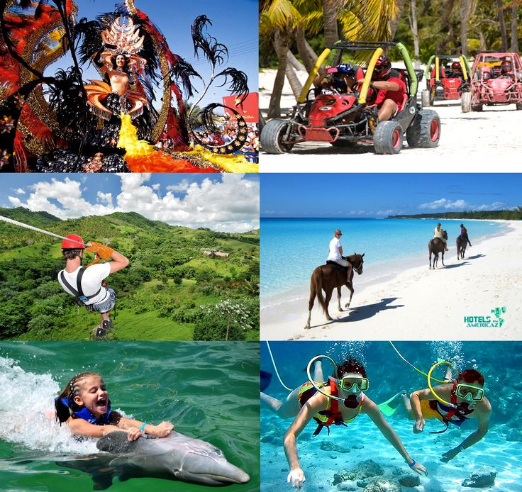

1. Business Tourism – People that they are still working and being paid, but they are just working away from their usual workplace and need to travel to new place to work for temporary period. Normally this group of people travel for businesses purpose, to complete a business transaction or attend business meeting.

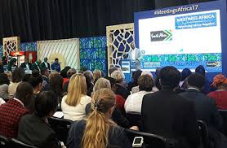

1. Nature Tourism – It is tourism based on the natural attractions to enjoy the natural nature. Examples include birdwatching, photography if wild life, hunting, fishing, visiting parks etc. These experiential tourists are interested in a diversity of natural and cultural resources. They want what is real, and they want to be immersed in a rich natural, cultural, or historical experience.

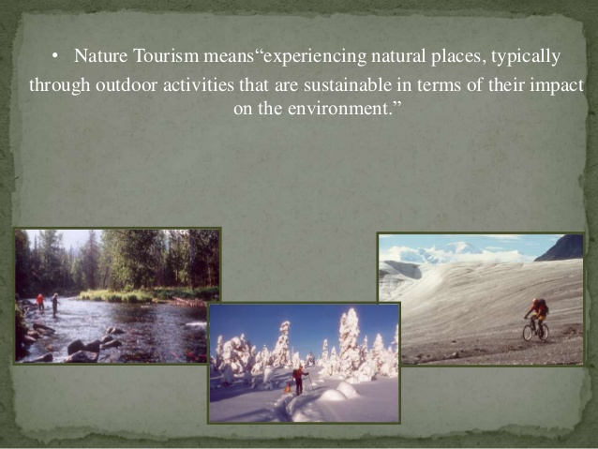

1. Educational Tourism – Educational tourism is developed because of the growing popularity of teaching and learning of knowledge and the enhancing of technical competency outside of classroom environment. In educational tourism, the main focus includes visiting another country to learn about the culture, study tours, or to work and apply skills learned inside the classroom in a different environment. Also experience the living style in that place.

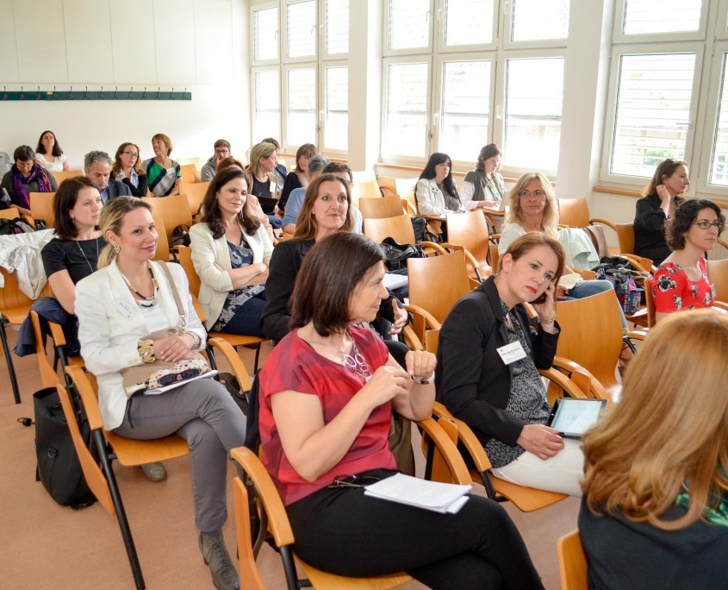

1. Recreation Tourism –To escape the routine of daily life style, people that work for long hours and almost daily routine are about the same. Home to office and office to home which they need to have a break escape/release their self from this boring routine. Example go for short trip for camping, surfing finds something that will get back fulfillment, enjoyment, relaxing and satisfaction feeling.

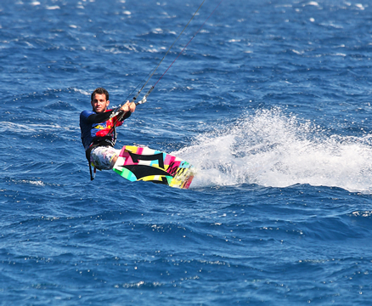

1. Sport Tourism – For some athletic that they need travel to other country to take part competition, in the mean while some of the fans of the sport team may also travel to that country to support. Example Olympics, FIFA world club, etc. also some people that travel to some certain place to experience some sport activities or any sport event.

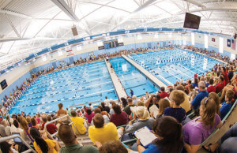

1. Religious Tourism – Religious tourism, people who believe that they can strengthen the religious elements of their self-identity in a positive manner, so they will visit a place to seek of spiritual. Example the largest form of mass religious tourism takes place at the annual Hajj pilgrimage in Mecca, Saudi Arabia.

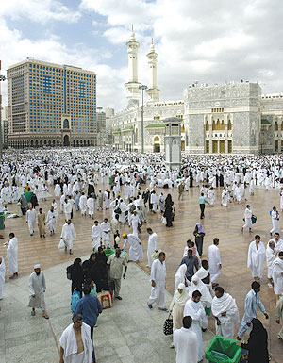

1. Health / Medical Tourism – People who need to travel to a country other than their own to obtain medical treatment due to some of the country their medical technology not that advance or do not have specialist doctor for some specific illness so that they need to travel to other country to get a better medication treatment. Some travel to other countries to seek for a lower price medical treatment.

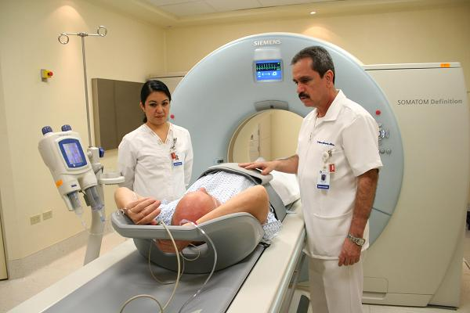

Tourism is an important sector that has an impact on development of country economy. The main benefits of tourism are income creation and generation of jobs opportunities. Tourism involve someone who is making a visit to a destination that outside his/her usual environment for less than a year for any main purpose such as holidays, leisure and recreation, business, health, education or other purposes.

**Question 3**

Describe the lodging accommodation and types of Hotel accommodation. (20 Marks)

Lodging is a place that for someone temporary to stay, for example someone that travel for holidays, work or study which away from home. Basically, lodging will provide basic need for traveler such as a place to sleep/rest, place that can get food, have a security/safety, a shelter that cover from cold temperatures bad weather, storage of personal belonging such as luggage, passport etc. and access to common household functions. There are few types of lodging accommodation such as a hotel, motel, hostel, cottage, resorts etc.

There are several types of accommodation such as: **(Luxury Accommodations)**

Hotel – Hotel is a very common accommodation that can easily find in every single place, that normally provides a shelter or a place for travelers to rest/sleep. But the range of price will be very different depend on the types of room, hotel location, amenities also the rated of the hotel which from one-star to five stars to determine the price of room per night. The higher rated hotel normally will be more expensive. There are several types of hotel such as Business Hotels – Primarily cater to business travelers and usually located in downtown or business districts, Airport Hotels – For passengers with overnight travel layovers or cancelled flights and airline crews or staff, Budget Hotel – Primarily for budget minded travelers who wants a room with minimum services and amenities, required for comfortable stay, without unnecessary paying additional cost for costly services.

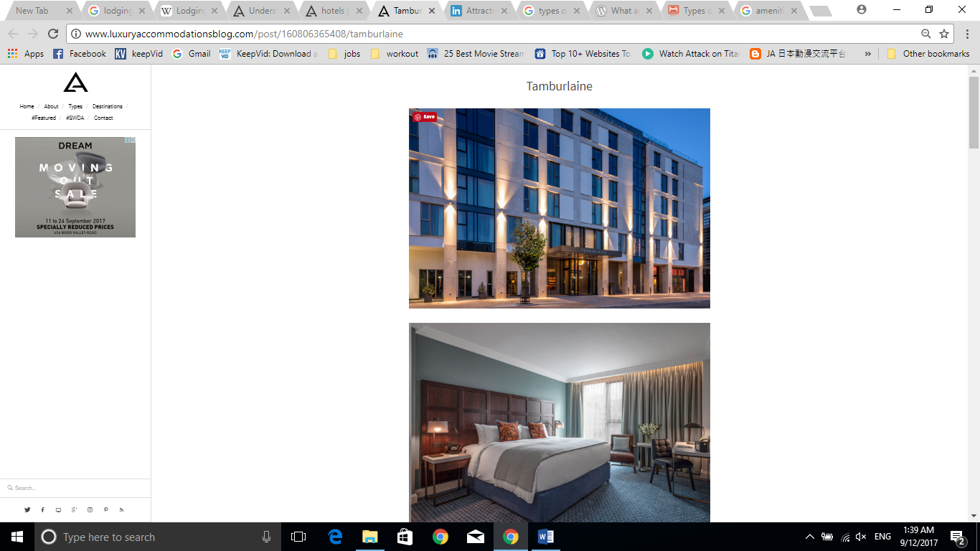

Tamburlaine - <http://www.luxuryaccommodationsblog.com/post/160806365408/tamburlaine>

Hostel – Hostel is an ideal place for budget travelers and backpackers, a hostel is an inexpensive type of accommodation, that usually need to shared bedrooms and communal facilities with other people. Some hostel may need to share bathrooms with other rooms which the bathrooms will locate outside of the bedroom and no also cannot choice of roommates and can be anyone. Some hostels may have private bedroom or bathrooms but need to pay an extra price. Mostly this kind of accommodation likely by the young single travelers.

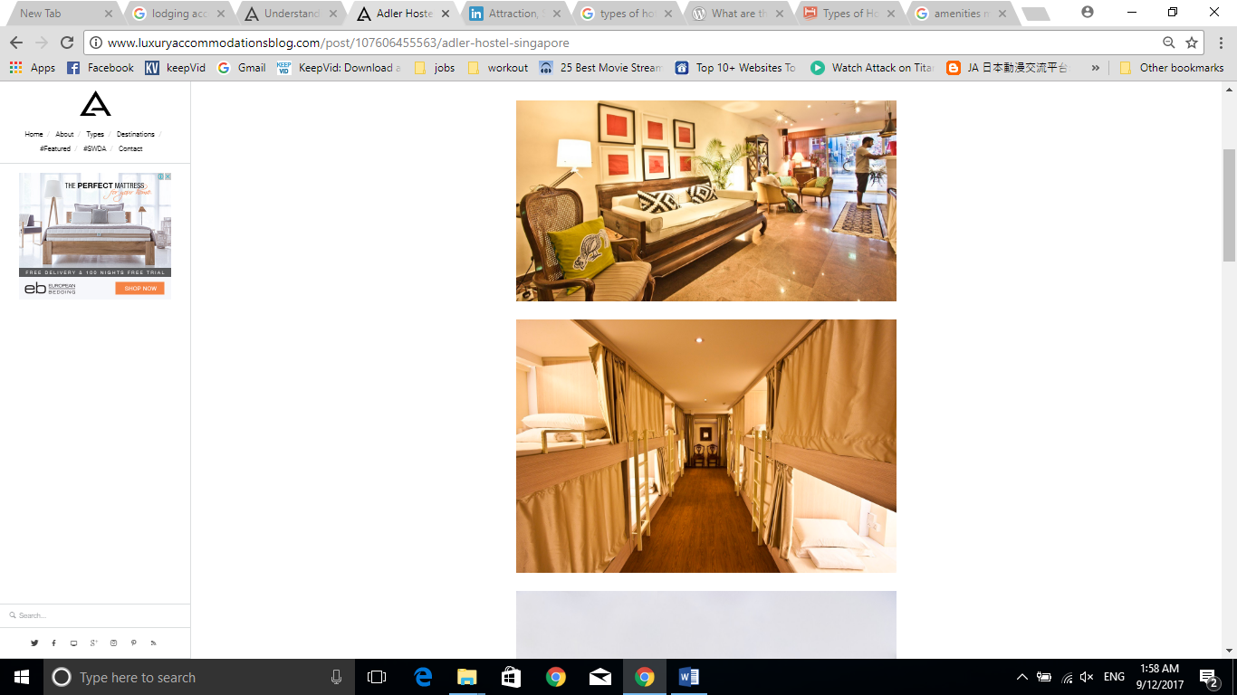

Adler Hostel – Singapore - <http://www.luxuryaccommodationsblog.com/post/107606455563/adler-hostel-singapore>

Cottage – Cottage are typically small homes, that specially design for vacationers that can rent and feel it as their own second home for the duration of their stay. The properties may be also owned by those rich people that will using them for once a while for vacation. It looks like a small vacation house normally build in a typical rural area.

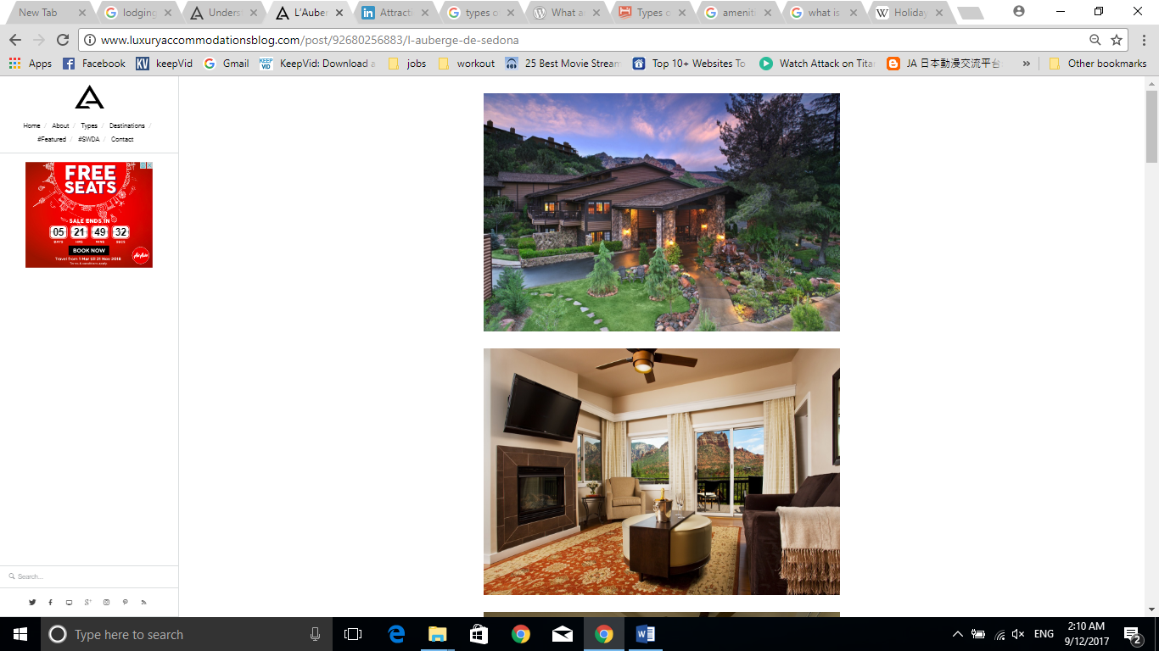

L’Auberge de Sedona - AZ, USA - <http://www.luxuryaccommodationsblog.com/post/92680256883/l-auberge-de-sedona>

Chalet – Chalets normally build up with wooden Alpine-style buildings, commonly found in the area around mountain, by the beach, in small island or beside lake. For people to escape from their busy city life style to get some natural, refreshing.

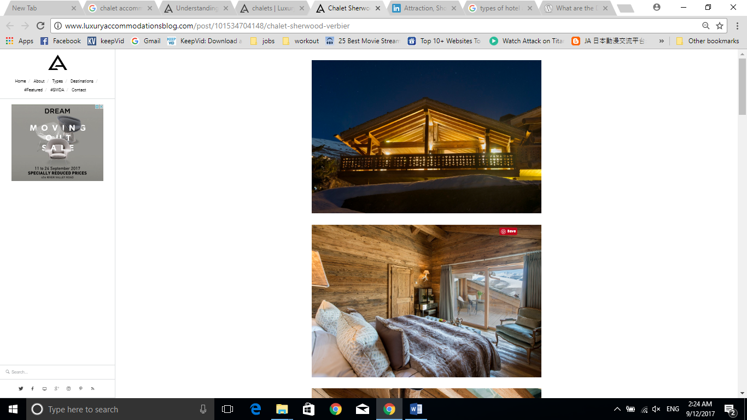

Chalet Sherwood - Verbier, Switzerland - <http://www.luxuryaccommodationsblog.com/post/101534704148/chalet-sherwood-verbier>

Resorts – Compare with other accommodation, resort will be a destination frequented visit by vacationers in search of relaxation and entertainment. Resorts are providing a wide verity of amenities and recreational facilities. It is more about the experience. Usually used for vacation or getaways. Normally, resort will provide some common areas amenities such as a swimming pool, dining, game room, workout facilities, etc. that you will find all the entertainment in one place.

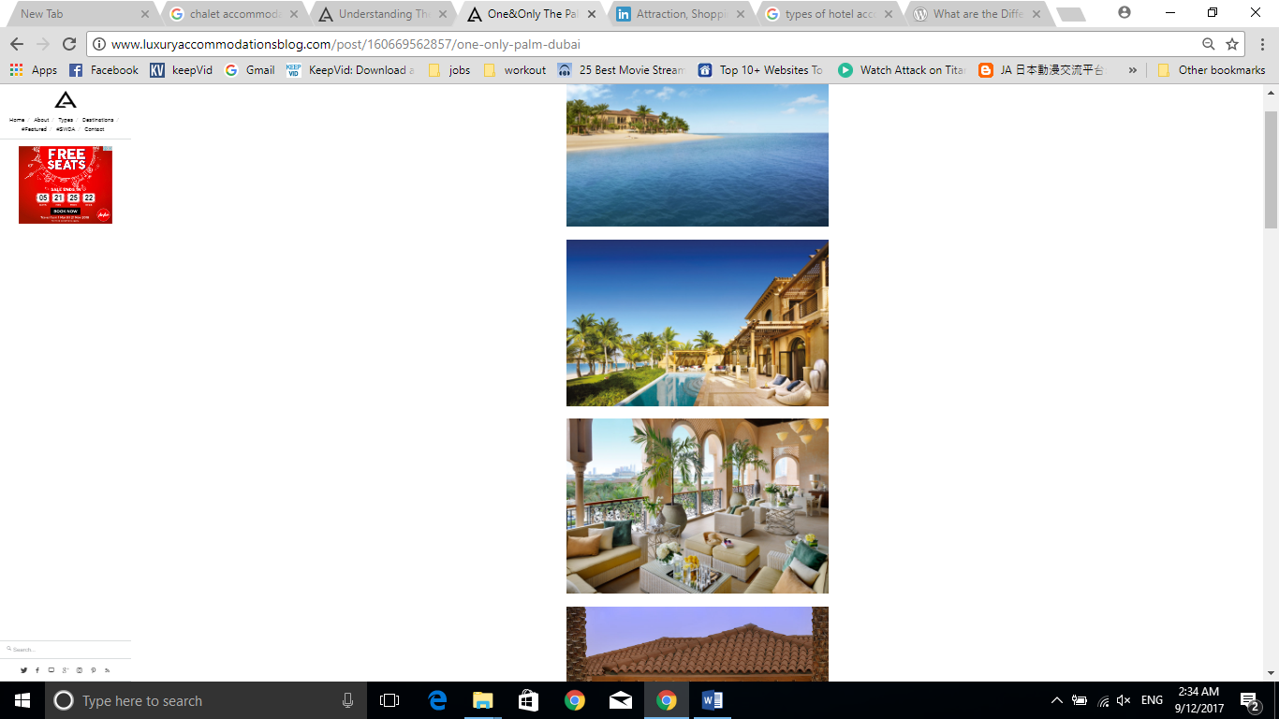

One&only The Palm, Dubai - <http://www.luxuryaccommodationsblog.com/post/160669562857/one-only-palm-dubai>

**Question 4**

Explain the Significant of Entertainment in this industry. (20 Marks)

Entertainment is a form of activities that help people to release stress after back from work or school and give them properly amusement to relax. In tourism industry, entertainment is a very important sector. Tourists would love to visit some specific places such as nigh clubs, water park, sports games, cruise and so on. Entertainment tourism create a larger opportunity for employment, and it happens to be the most diverse. Some jobs in recreation and entertainment field include marine facilities, parks and attractions, outdoor adventure and ecotourism etc. Entertainment also one of the fastest growing tourism industry.

Different types of entertainment: **(in slideshare)**

Parks and Attractions - Attractions can include historic sites, heritage homes, museums, halls of fame, art galleries, botanical gardens, aquariums, zoo, water and amusement parks, casinos and cultural attractions. Amusement Park where a place that offers rides, shows, food, candy, and arcades. Aquarium an aquatic zoo that features a wide variety of fish and sea creatures in tanks for viewing by the public. Casino Gambling including slot machines, roulette, craps, blackjack, poker and other games of chance that entertain people. Heritage or Cultural Tourism an immersion in the natural history, human heritage, arts, philosophy, and institutions of another region or country.

Mall - A large shopping and entertainment center offering a wide assortment of services including retail stores, restaurants, etc. as well as a variety of entertainment facilities such as indoor theme parks, game rooms, wave pools, mini golf courses, cinemas, etc. some mall also have some bar/night club entertainment for people where can chills and release.

Marine Facilities - Visitors alike enjoy water and water-based activities, such as fishing, swimming, sailing, windsurfing, water-skiing, canoeing, etc. Related businesses include marinas, tour boat excursion or rental operators, sport-fishing lodges, and fly-in fishing camps. There are marine businesses offering exciting activities such as whale-watching, kayaking and deep-sea fishing. This sector requires employees as guides, instructors, business operators and more.

Sport and game - Many travelers seek adventure, challenge and excitement in the fabulous outdoor settings such as hiking, cycling, mountaineering, canoeing, kayaking, sailing, horseback riding, river rafting, scuba diving, sky diving, snowmobiling, and nature and wildlife viewing are just some of the activities included in this industry of the tourism sector. Example there are large numbers of Canadians and foreign visitors love Canada’s many golf and tennis facilities. As with ski resorts, this industry needs employees to sell clothing and sports equipment, maintain and repair facilities and equipment, and train players.

**Conclusion**

Tourism and Hospitality are multibillion-dollar industry that creating jobs and bringing substantial of revenue worldwide. To truly understand the principals behind tourism and hospitality, the course work first defines both terms in its own definition, for instance, Tourism defined as activities of persons travelling to and staying in places outside their usual environment for leisure, business and other purposes; whereas Hospitality defined as the relationship between guest and host, or the act of bring hosted. Tourism encompasses some huge sub-industries which covers accommodation, retail operations, tourist attractions, entertainments, transportations, government, catering and information services. Each year, the industry provided countless income and job opportunities throughout the globe and even serves as main source of income for certain countries like Maldives, Bahamas, Macau and Cambodia, to name a few. Understanding Tourism and Hospitality management would allow us to better comprehend the complexity and understand the networks that intertwine each facet like resort, tourism, hotel, event and convention management; as well as skills and fields of study essential to the industries.

As conclusion, the coursework offers a great chance in understanding the essentials of both Hospitality and Tourism industry, both industries overlapping and needing each other to survive and thrive, and within them, there are more distinct sub division of studies that require further understanding. Given the importance of the subject to social and economy, the coursework and the subject did inspire me to deepen my knowledge in Tourism and Hospitality industry as I strongly believe it will be beneficial in my future.

**References**

1. Figure 1 - <http://cte.sfasu.edu/wp-content/uploads/2014/02/Hosp_Tour.pdf>
2. Online - Tugberk Ugurlu, Definintion of Tourism (UNWTO Definition of Tourism) / What Is Tourism ? , Tugberk Ugurlu, 2010 - <http://www.tugberkugurlu.com/archive/definintion-of-tourism-unwto-definition-of-tourism-what-is-tourism>
3. Pleasure tourism -<https://i.pinimg.com/736x/71/8d/3c/718d3c4dcf2200f3fd9a6a18ae96811e--punta-cana-dominican-republic-vacation-destinations.jpg>
4. Business tourism - <https://encrypted-tbn3.gstatic.com/images?q=tbn:ANd9GcS29h9ukjDFQz_VQngyhs-3bqOL_tQUDv5SNR25ltrkBJcrvLLiyw>
5. In slide share - <https://image.slidesharecdn.com/naturetourism-130713232753-phpapp01/95/nature-tourism-3-638.jpg?cb=1373758130>
6. Educational Tourism - <http://infota.org/wp-content/uploads/2016/07/20160615_12_02_02_DSC0329-766-845x684.jpg>
7. Sport Tourism - <http://www.sports-management-degrees.com/wp-content/uploads/2014/07/USA-Swimming-Championships-300x194.jpg>
8. Religious Tourism - <https://upload.wikimedia.org/wikipedia/commons/0/00/Makkahi_mukarramah.jpg>
9. Health / Medical Tourism - <https://fm.cnbc.com/applications/cnbc.com/resources/img/editorial/2014/03/13/101492395-Mexico_hospital.600x400.jpg?v=1394734046>
10. Online - Luxury Accommodations <http://www.luxuryaccommodationsblog.com/post/114961446726/different-types-accommodation-tourism>
11. Online - in slideshare <https://www.slideshare.net/roopeshv149/attraction-shopping-entertainment-components-of-tourism>

**Appendix**

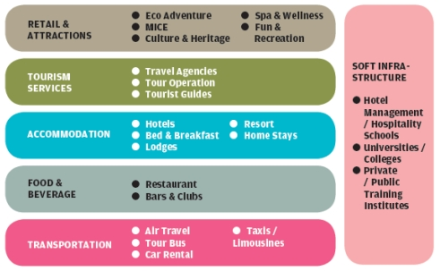

<http://mystarjob.com/articles/story.aspx?file=/2013/10/26/mystarjob_careerguide/13753548&sec=mystarjob_careerguide>

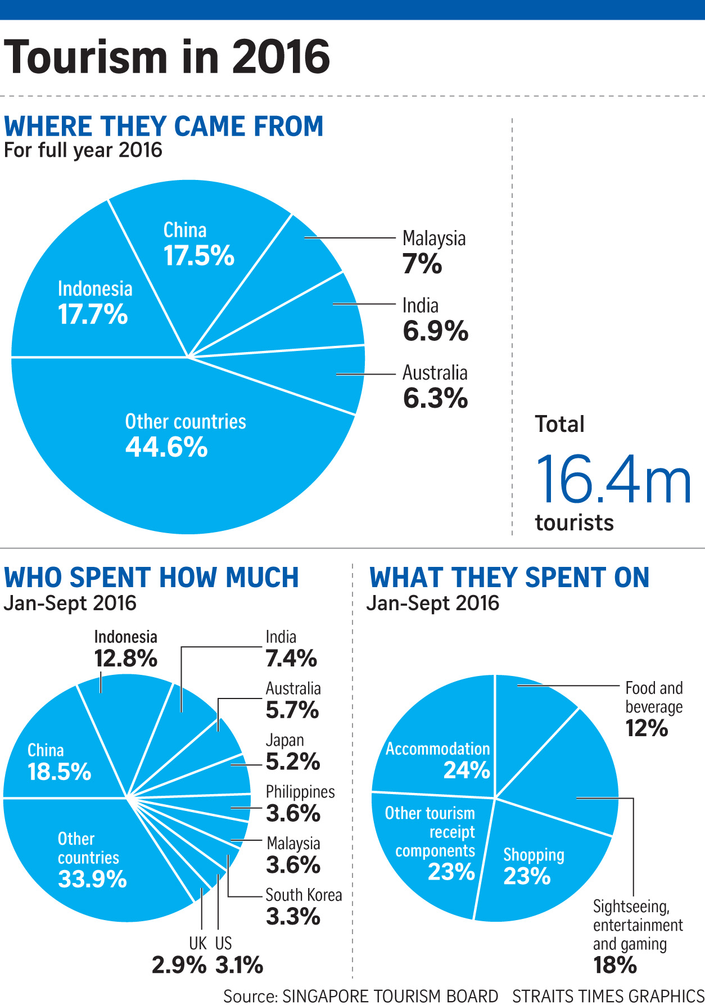

<http://www.straitstimes.com/singapore/tourist-spending-and-arrivals-hit-new-highs>

THE END